**Pre Requisites-IBM Cloud Services**

|  |  |
| --- | --- |
| **TEAM ID** | PNT2022TMID08488 |
| **Project Name** | GAS LEAKAGE MONITORING AND ALERTING SYSTEM FOR INDUSTRIES |
| **Leader Name** | RUBASHREE S |
| **Team Members Name** | RAMANIKA R  KEERTHIKA R  VIDHYAV |

**DASHBOARD:**

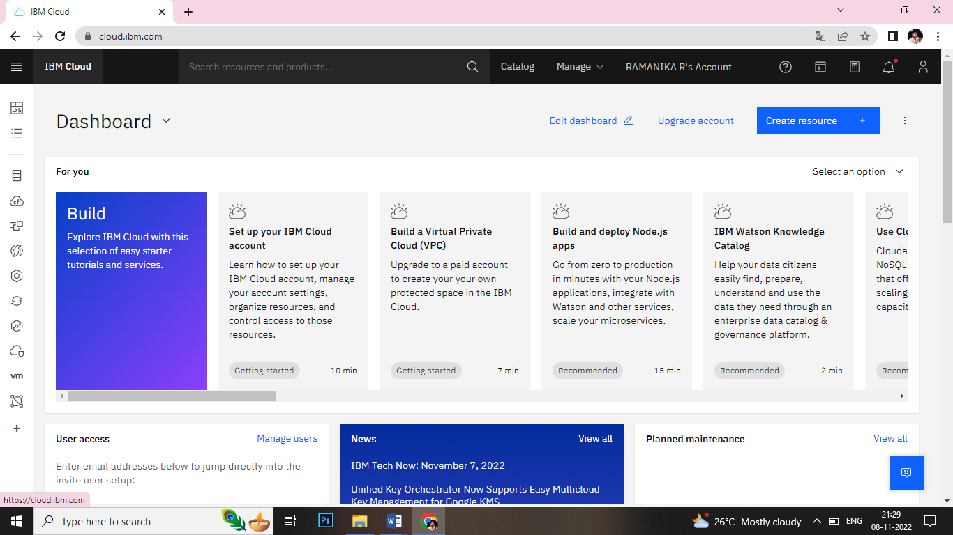

**ACCOUNT SETTINGS:**

